Assignment Module 1 HTML
Question 1. Are the HTML tags and elements the same thing?
Answer: No HTML tags and elements are not the same thing. An element consists of opening tag, closing tag and content between them. HTML tags are starting and ending part of HTML.

Question 2. What are tags and attributes in HTML?
Answer: Tags are starting and ending part of HTML enclosed by angle brackets.
Attributes are used inside the opening tag and provides extra details about behavior of the element.

Question 3. What are void elements in HTML?
Answer: Void elements in HTML are the tags that do not have any content or the closing tag, also called as empty tags. Ex. <br>,<hr>, etc.
Ex. 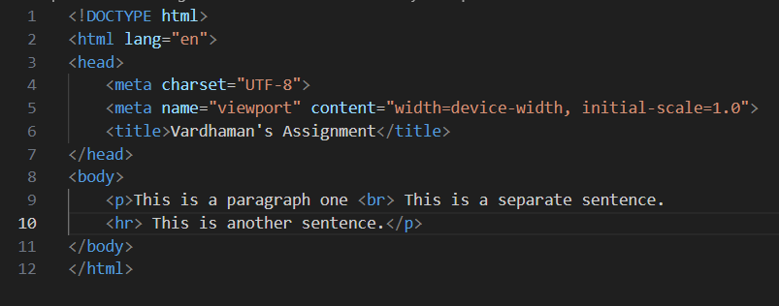

Question 4. What are HTML Entities?
Answer: HTML entities are special characters that can be used to display symbols or icons that are not available on a keyboard.
Ex. 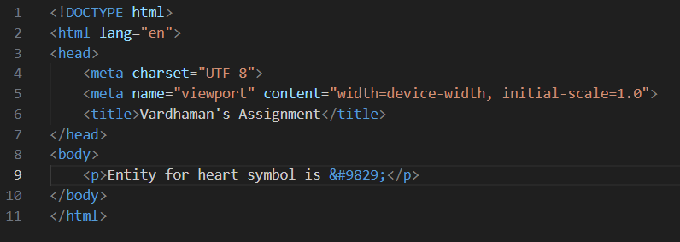

Question 5. What are different types of lists in HTML?
Answer: There are 3 types of lists in HTML Ordered list, Unordered list, Description list.

Question 6. What is the ‘class’ attribute in HTML?
Answer: HTML class attribute is used to point to a class name in a style sheet. Classes are used by CSS and JavaScript to manipulate specific elements.

Question 7. What is the difference between the ‘id’ attribute and the ‘class’ attribute of HTML elements?
Answer: HTML id attribute is used to specify a unique id for an HTML element. A class name can be used by multiple HTML elements, while an id name must only be used by one HTML element within the page.

Question 8. What are the various formatting tags in HTML?
Answer: Formatting tags in HTML are used to change the appearance or meaning of the text. Examples: <b>,<strong>,<em>,<i>,<u>, etc.
Ex. 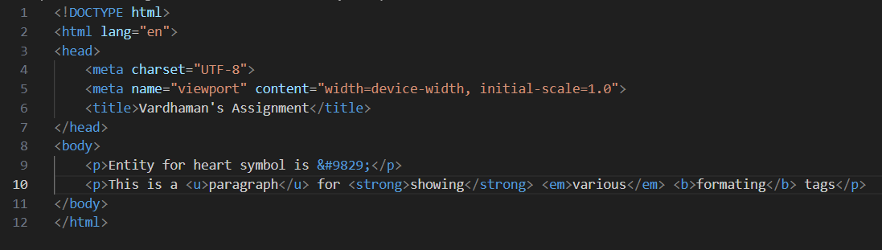

Question 9. How is Cell Padding different from Cell Spacing?
Answer: Cell spacing will determine space between the cells while cell padding will determine space between content and it’s cell borders.
Ex. 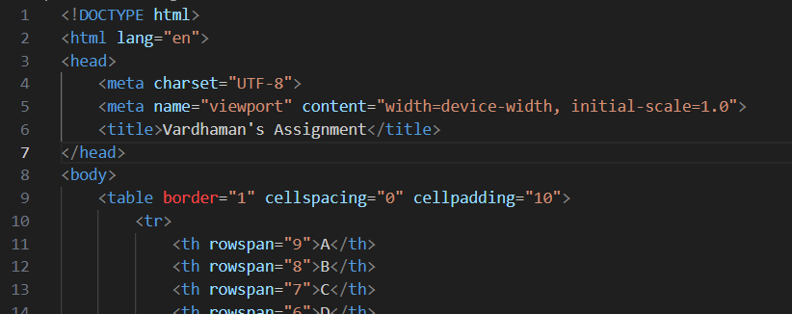

Question 10. How can we club two or more rows or columns into a single row or column in an HTML
table?
Answer: Colspan and Rowspan are attributes that can be used in tables for clubbing together two or more columns and rows respectively.
Ex. 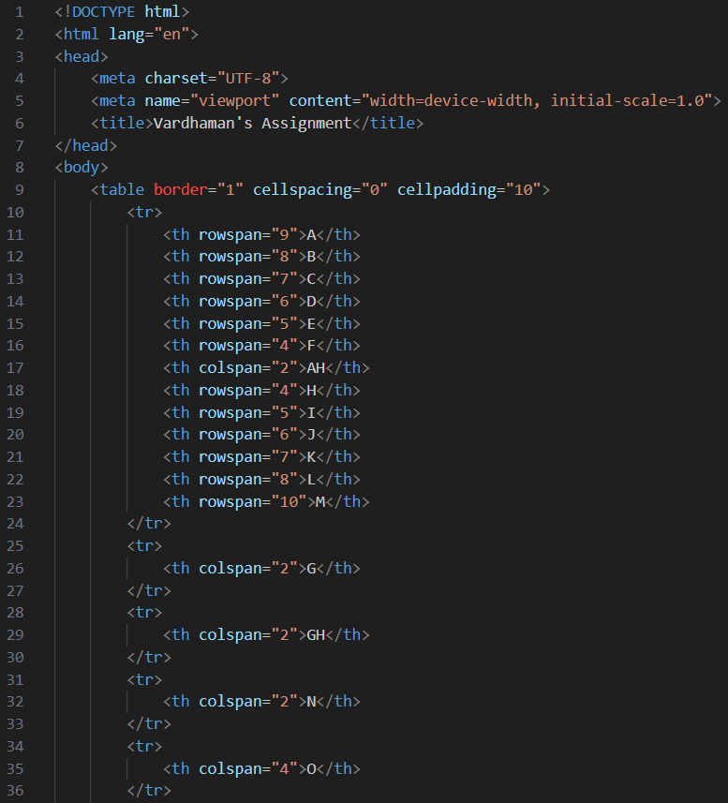
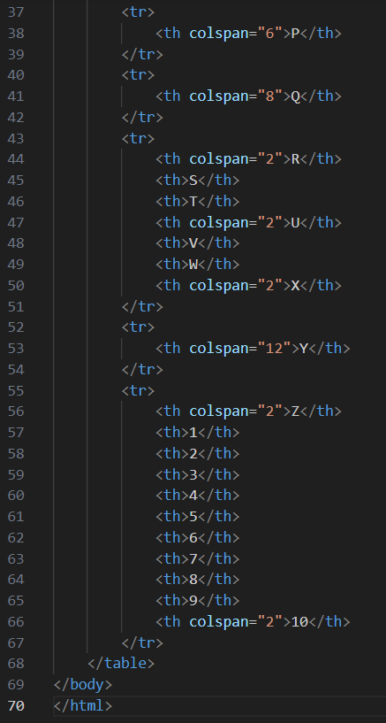

Question 11. What is the difference between a block-level element and an inline element?
Answer: A block level element starts on a new line and takes up the full width available, while an inline element continues on the same line and only takes up width as necessary.

Question 12. How to create a Hyperlink in HTML?
Answer: Hyperlink is created by use of <a> tag along with its attribute href.
href specifies the destination of the link.
Ex. 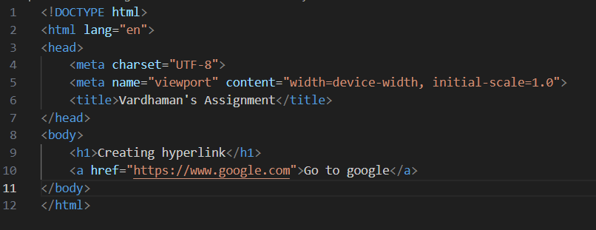

Question 13. What is the use of an iframe tag?
Answer: iframe tag is used to embed another webpage within current HTML webpage. It allows us to view content from other sources without leaving current webpage.
Ex.
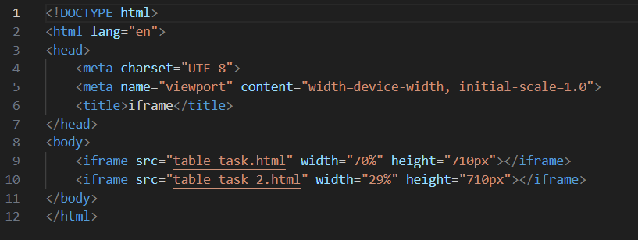

Question 14. What is the use of a span tag? Explain with example?
Answer: Span tag is used to apply styles or effects to the inline text.
Example: 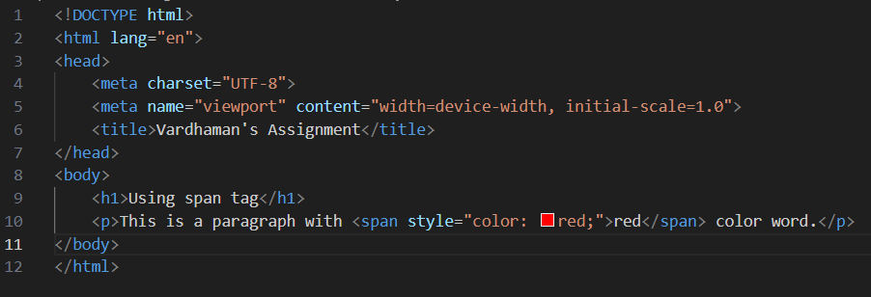

Question 15. How to insert a picture into a background image of a web page?
Answer: To insert a picture into a background of a web page, we can use background attribute in the body tag of the html document.
Ex. 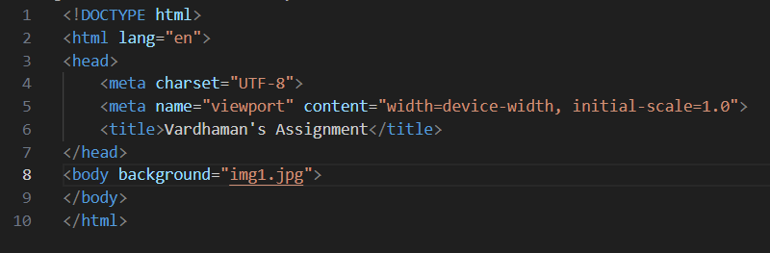

Question 16. How are active links different from normal links?
Answer: Normal links are links that have not been clicked by the user. Active links are links that are currently being clicked by the user.

Question 17. What are the different tags to separate sections of text?
Answer: To separate sections of text, we can use various tags such as, <p> for paragragh, <br> for line break, <hr> for horizontal line, <div> for division of the section, <header>, <footer>, etc.

Question 18. What is SVG?
Answer: The SVG tag (Scalable Vector Graphics) allows you to create and display vector-based graphics in XML format, using various methods for drawing boxes, circles, and graphic images.

Question 19. What is difference between HTML and XHTML?
Answer: HTML stands for Hypertext Markup Language, while XHTML stands for Extensible Hypertext Markup Language. HTML is more easy going in its syntax, while XHTML has a more strict syntax.

Question 20. What are logical and physical tags in HTML?
Answer: Logical tags describe the meaning of the text, while physical tags specify the appearance of the text. For example, <strong> is a logical tag that indicates important text, while <b> is a physical tag that makes the text bold.

